Problem Statement
Police departments need a quick, robust description of “typical” crime severity to size baseline resources and to communicate risk to command staff. Using a sample of 40 recent crime records, we compute the three classic measures of central tendency (mean, median, mode) of the severity_score (1–10 scale) and produce an audience-aware interpretation.

Solution Strategy
1. Extract the severity vector from crimes.csv. 2. Compute mean (sum/n and mean()), median (sort + median()), and mode (frequency table + custom function). 3. Overlay all three on a single histogram. 4. Write two versions of the takeaway: detailed for analysts, headline-first for commanders. 5. Run a small Monte-Carlo noise simulation to check robustness of each measure.

Solution
Results: Mean ≈ 5.41, Median = 5.1, Mode is multimodal (several scores appear twice; the first maximum returned by the custom function is typically 3.9 or 3.2). The distribution is mildly right-skewed, so the mean sits slightly above the median.
Visual: Histogram of severity with vertical reference lines (red = mean, blue dashed = median, green = mode).
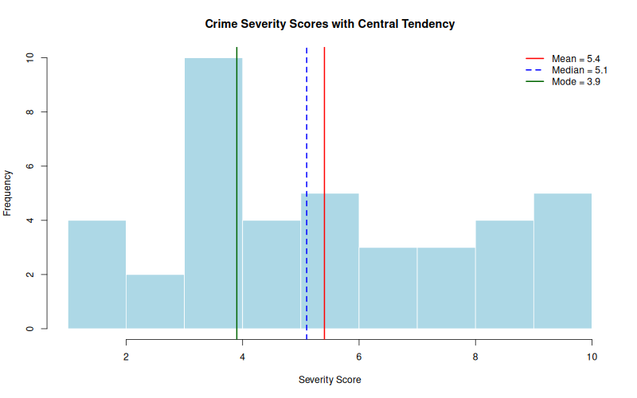
Analyst takeaway: Mild right skew and multi-modality; median is the preferred single number for centre-seeking models; inspect the high-severity tail separately.
Commander headline: Typical severity ≈ 5.1 (median). Average is a little higher (5.4) because of a few very serious incidents. Size baseline capacity to the median; reserve surge capacity for the high-severity tail.

Key Takeaways
• Prefer the median when communicating “typical” severity to decision makers; the mean is pulled upward by the severe tail.
• Mode is not unique here — report the multi-modal nature rather than a single number.
• Audience adaptation is essential: analysts receive distributional detail; commanders receive a headline + clear so-what.
• Monte-Carlo noise simulation (noise_sd = 0.5) confirms both mean and median remain stable; always re-check robustness when the data-generating process changes.

